
AUTOMATION 6 WEEK REPORT
WEEK-1
Introduction to BEUMER
- Learned about BEUMER Group and its global presence.
- Understood the company’s role in intralogistics and automation solutions.
- Gained an overview of BEUMER’s products and services in airport, logistics, and warehouse automation.
- Learned about BEUMER’s focus on efficiency, reliability, and sustainability.

Introduction to BHS & PMS
- Studied the basics of Baggage Handling Systems (BHS) used in airports.
- Understood how BHS ensures efficient baggage transportation, sorting, and tracking.
- Learned about Pallet Management Systems (PMS) and their importance in warehouse and logistics operations.
- Understood how automation improves material handling and operational efficiency.
Understanding of Software, Network, Server & Security
- Gained basic knowledge of software systems used in industrial and IT environments.
- Learned fundamental networking concepts such as LAN, IP addressing, and data communication.
- Understood the role of servers in hosting applications and managing data.
- Learned basic security concepts including authentication, firewalls, and data protection.
Introduction to AI & Data Analytics
- Learned the fundamentals of Artificial Intelligence and its applications in industry.
- Understood the basics of data analytics and its role in decision-making.
- Gained insight into how AI and analytics can optimize systems and improve performance.
- Learned about real-world use cases of AI and data analytics in automation and logistics.
Project Of data Analysis:
The project involved simulating multi-function energy meter (MFM) data using Node-RED, processing and converting it into Elasticsearch Bulk NDJSON format, and storing it efficiently in Elasticsearch. The ingested data was visualized using Kibana dashboards to monitor electrical parameters such as current, voltage, power, and energy consumption for JK Cement Plant equipment.

Technologies Used
- Docker (Containerized deployment)
- Node-RED (Data simulation & processing)
- Elasticsearch (Time-series data storage)
- Kibana (Real-time dashboards & visualization)
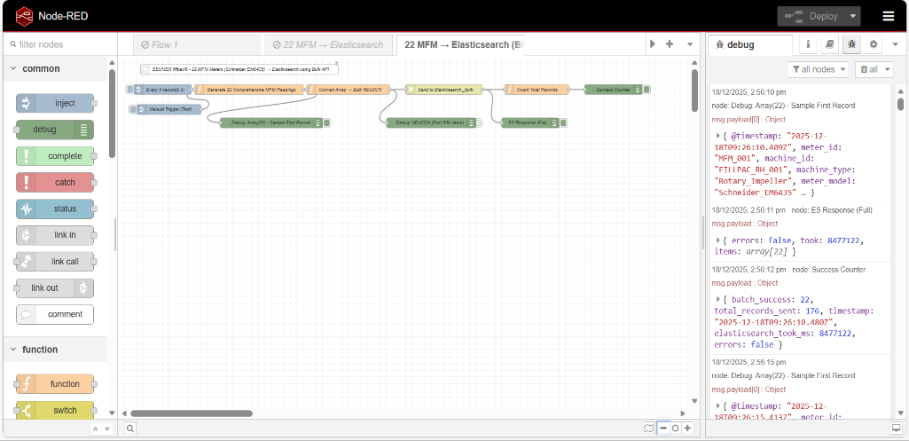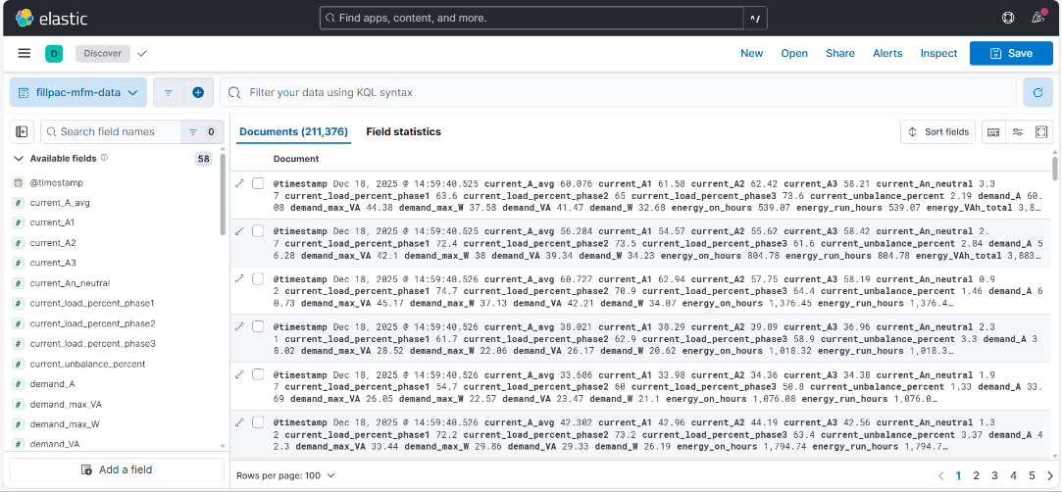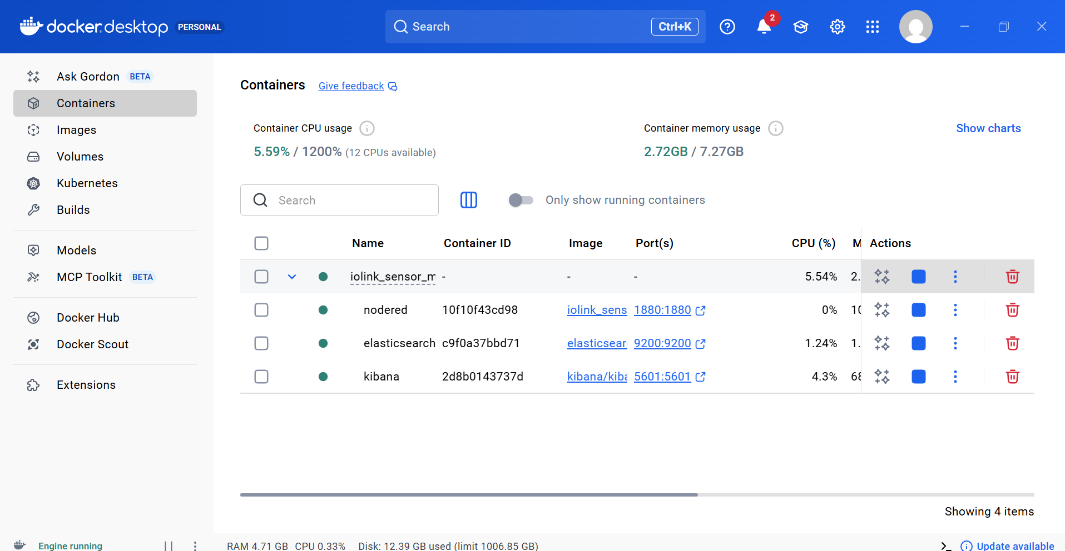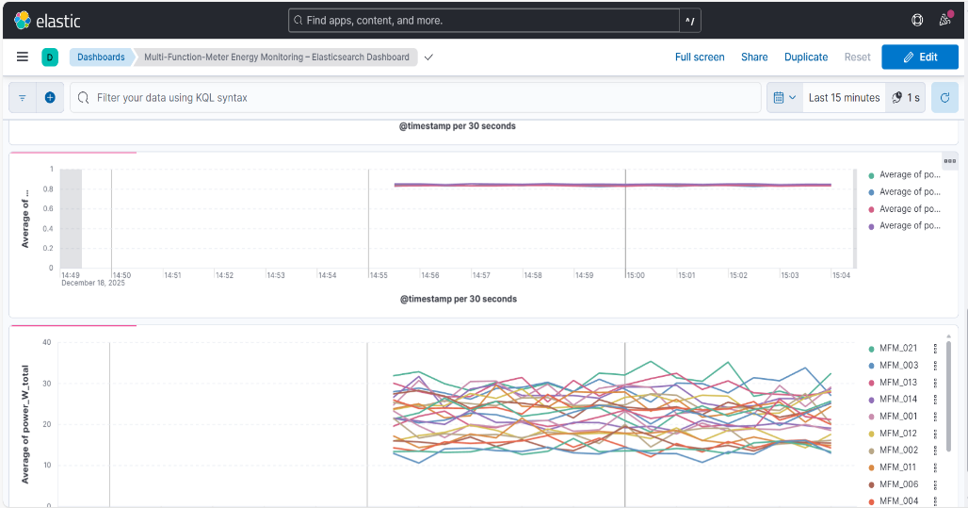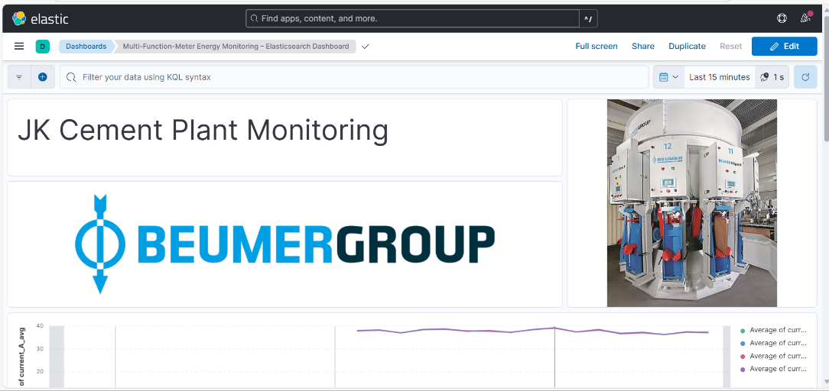

WEEK-2
Introducing IPv4 and IPv6
As part of the internship training, an introduction to Internet Protocol versions IPv4 and IPv6 was provided to understand device identification and communication within industrial networks. IPv4 addressing, which is widely used in existing enterprise systems, and IPv6 addressing, which supports large-scale and future-ready network architectures, were studied. Emphasis was placed on address structure, functionality, and their importance in reliable data transmission across automated systems.

Building a Simple Network
During the training, a basic network topology was designed and implemented using Cisco Packet Tracer. The network included end devices, switches, routers, and servers to simulate real-world industrial and enterprise environments similar to those used in BEUMER systems. This activity helped in understanding device roles, network connectivity, IP configuration, and data flow within a Local Area Network (LAN), which is essential for automated material handling and control systems.

Network Device Security
This module focused on understanding basic network security practices required to protect critical infrastructure. Training covered securing routers and switches through password protection, interface management, and access control. The importance of network security in preventing unauthorized access and ensuring continuous system availability in industrial automation environments was emphasized.

Troubleshooting Basic Connectivity
Basic network troubleshooting techniques were practiced to identify and resolve connectivity issues. This included verifying physical connections, checking IP addressing, monitoring interface status, and using diagnostic tools such as ICMP (ping). These troubleshooting skills are essential for maintaining uninterrupted communication in operational systems and minimizing downtime in industrial networks.

Conclusion
The training provided practical exposure to fundamental networking concepts relevant to BEUMER’s automated and intralogistics systems. The hands-on exercises enhanced understanding of IP addressing, network design, device security, and troubleshooting, contributing to a strong foundation in industrial networking and system reliability.

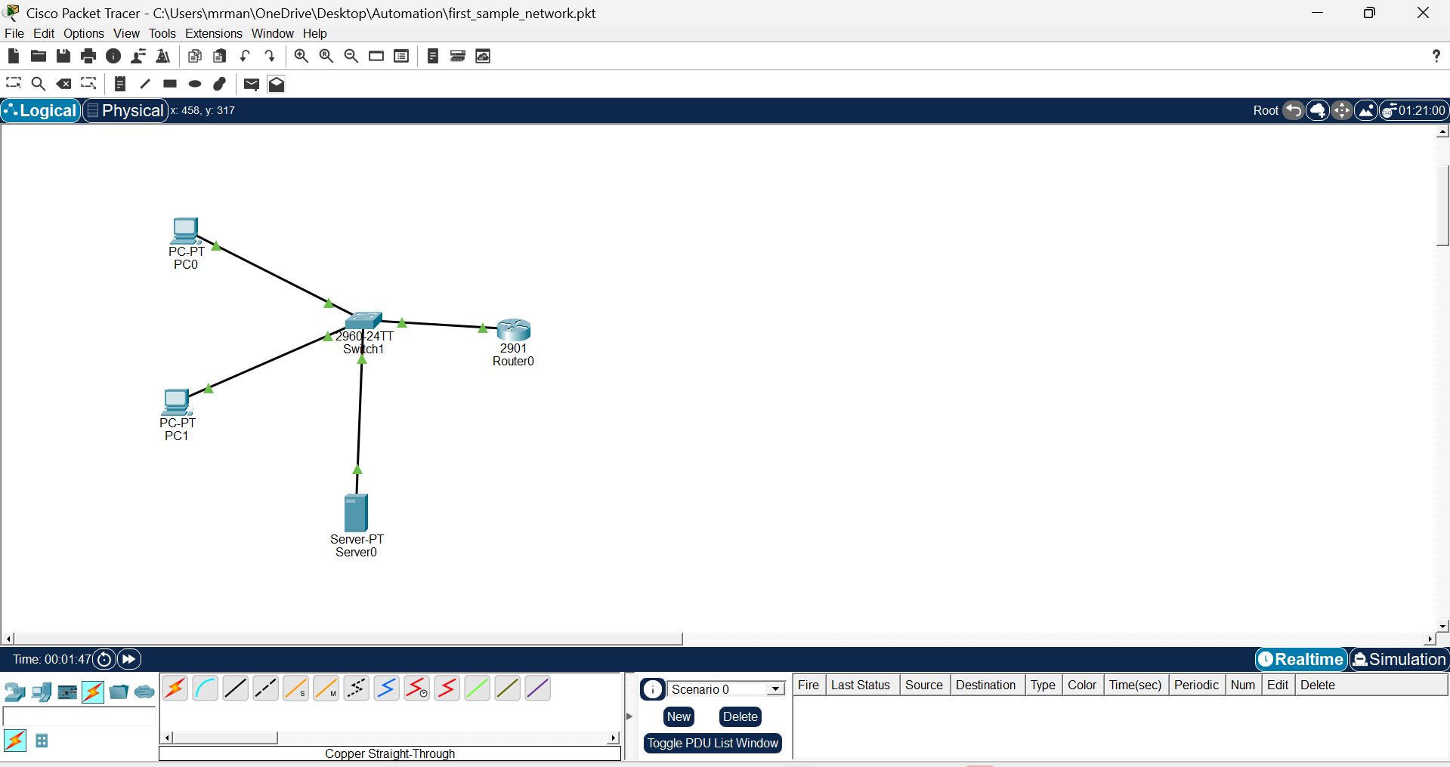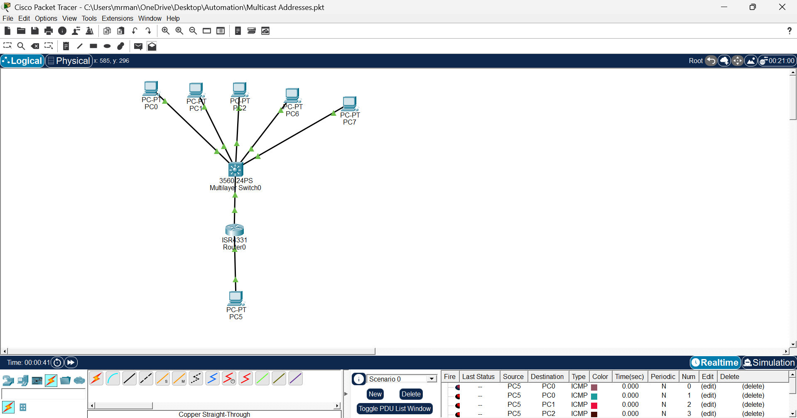
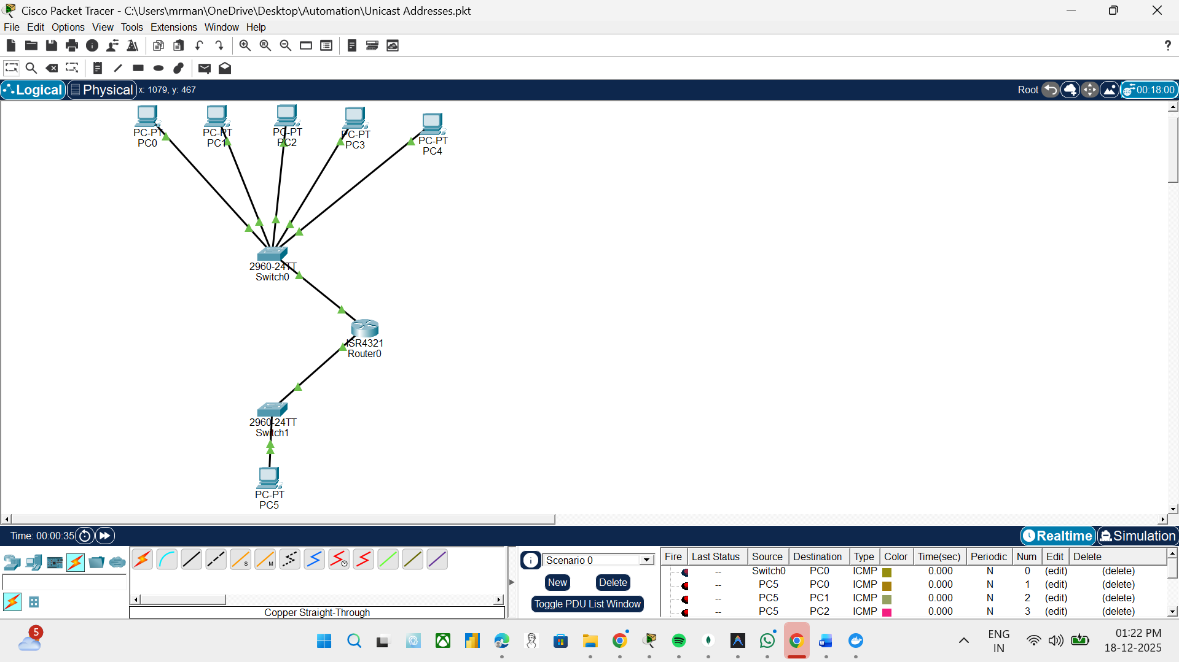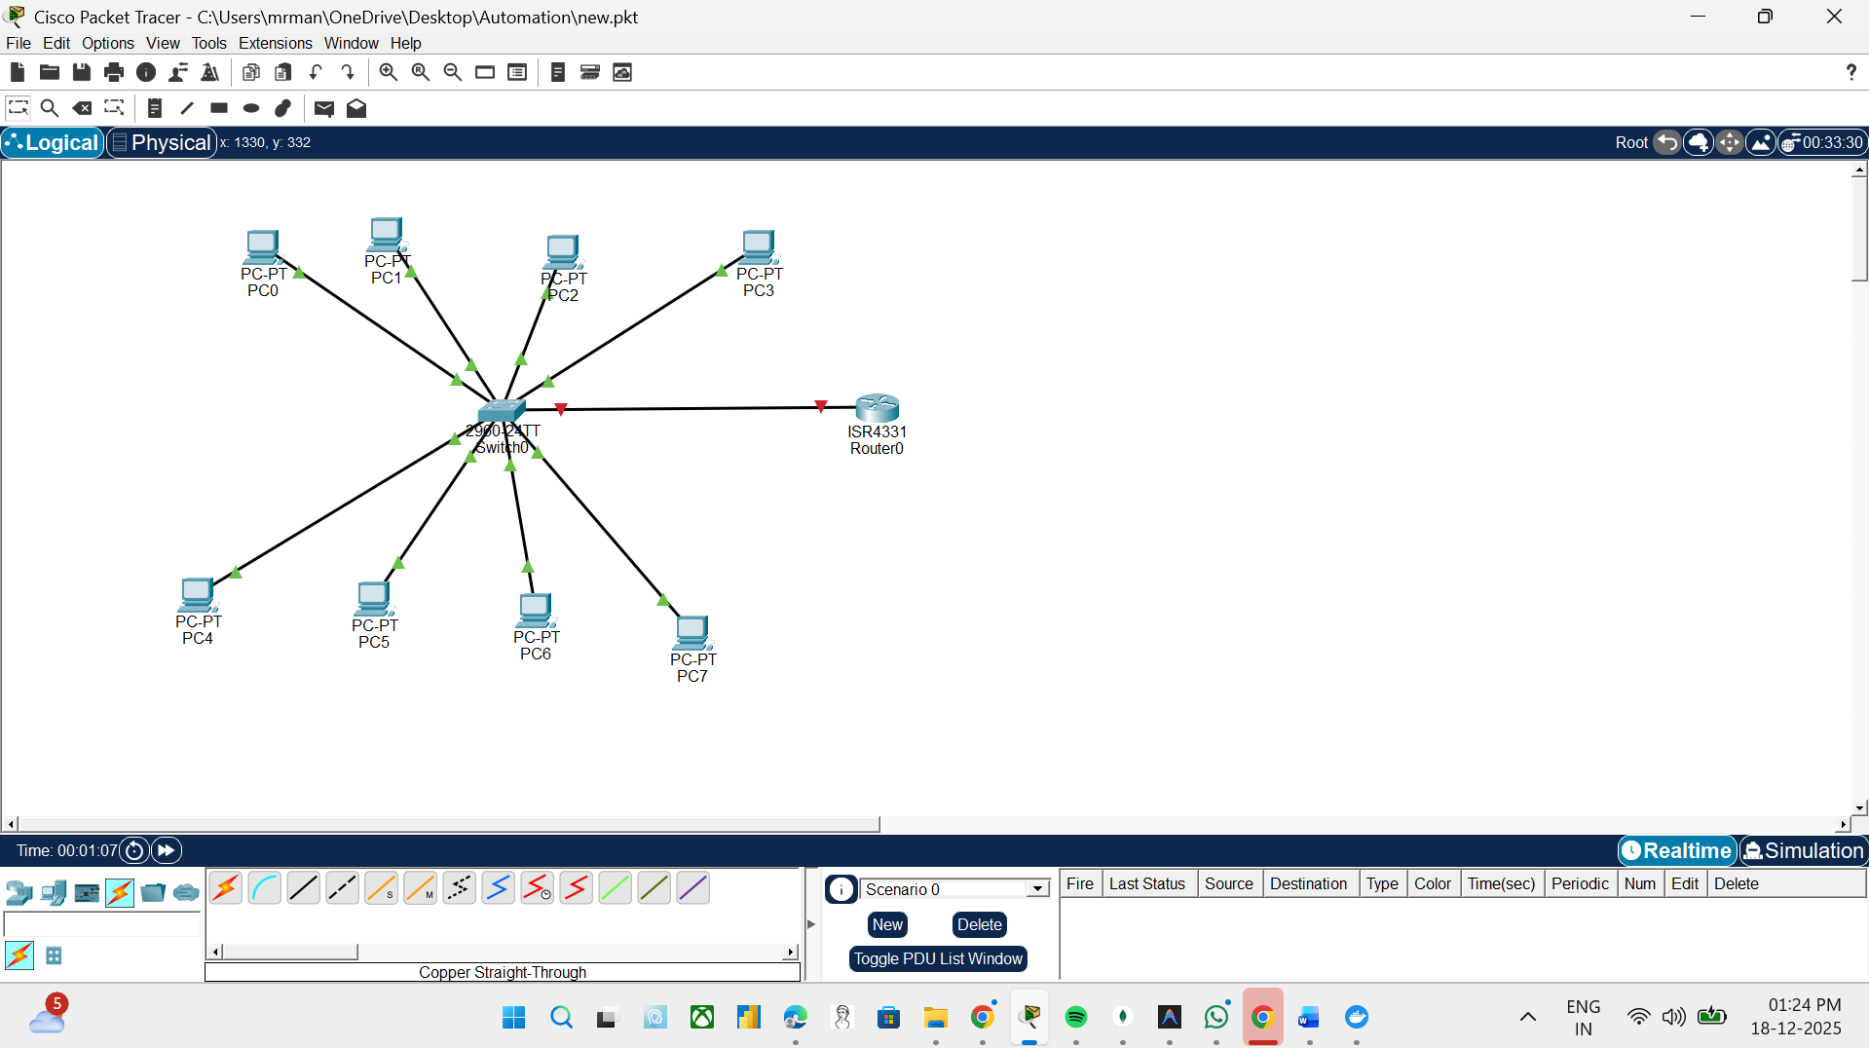
GitHub:https://github.com/mr-mandeeprana/Computer-Networking-Labs-Cisco-Packet-Tracer.git
WEEK-3
Basic Networking Concepts and Campus Network Design
During Week-3 of the training, fundamental networking concepts and practical network design were applied through a campus network project using Cisco Packet Tracer. The focus was on understanding how structured networks support automation and enterprise environments.
Basic Concepts and Network Design
Basic networking concepts such as LAN architecture, IP addressing, routing, and switching were revised and applied while designing a reliable network. A hierarchical approach was followed to improve scalability, performance, and ease of management.
Campus Network Design
A campus network design was implemented consisting of a Central Campus and an East Campus, interconnected through routers. Each campus included switches, servers, and end devices representing classrooms, offices, labs, and dormitories. This design reflects real-world industrial and enterprise networks used in automated systems.
Project link: https://github.com/mr-mandeeprana/Campus-Network-Design-Cisco-Packet-Tracer.git
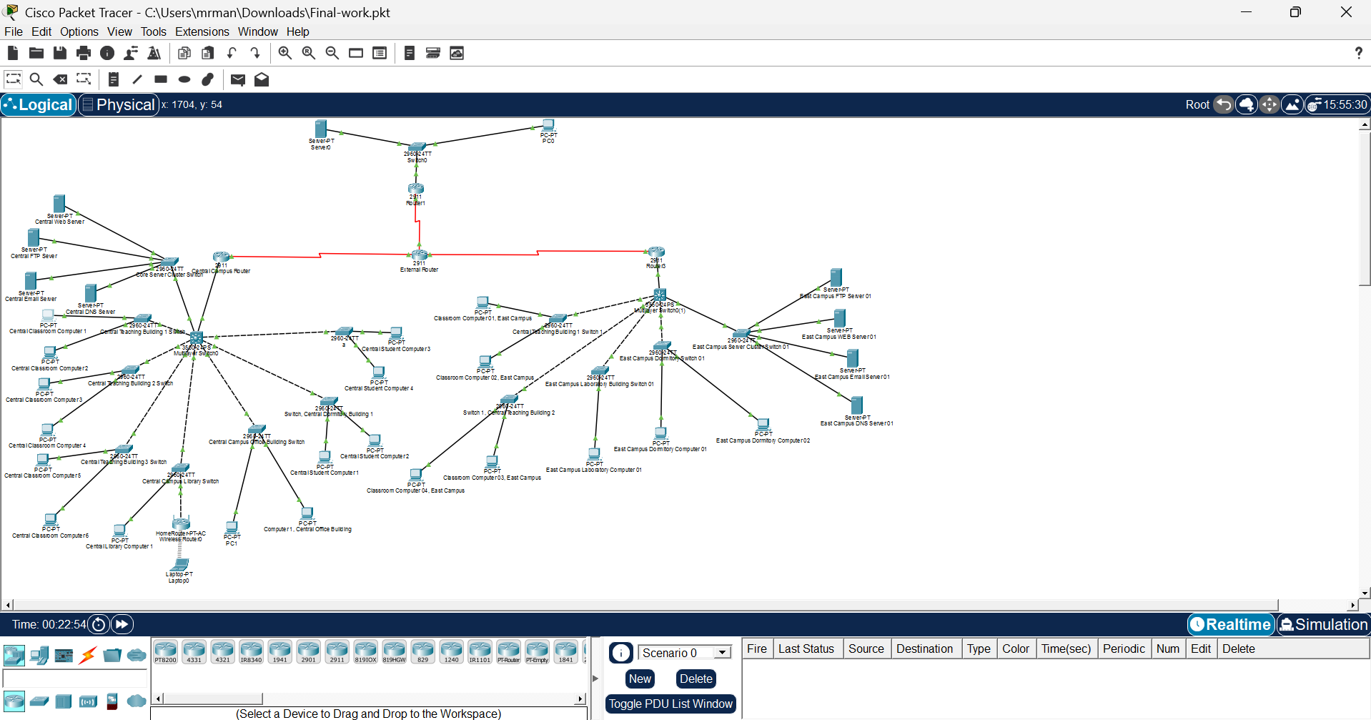
Configuring VLAN and Spanning Tree
VLANs were conceptually configured to logically separate departments and reduce broadcast traffic, improving network efficiency. Spanning Tree Protocol (STP) was studied to understand loop prevention and ensure network stability in environments with multiple switches.
Configuring Network Security
Basic network security configurations were introduced, including securing routers and switches using passwords, access control, and interface management. The importance of network security in protecting data, servers, and automated systems from unauthorized access was emphasized.
Conclusion
This week strengthened practical knowledge of campus network design, VLANs, spanning tree, and network security, which are essential for building secure and efficient networks in automation and industrial environments.
WEEK-4
Introduction to Server Infrastructure
Server infrastructure refers to the combination of hardware, software, network components, and storage systems used to host applications, manage data, and provide services to users. It includes physical servers, operating systems, networking devices, and management tools. A well-designed server infrastructure ensures high availability, performance, security, and scalability, which are essential for enterprise and automation environments.

Introduction to SAN & Virtualization
Storage Area Network (SAN) is a high-speed dedicated network that provides centralized and shared storage to servers, enabling fast and reliable data access.
Virtualization allows multiple virtual servers to run on a single physical server using a hypervisor, improving hardware utilization and flexibility. Together, SAN and virtualization form the backbone of modern data centers by enabling efficient resource sharing, scalability, and disaster recovery.

Basics of Physical and Virtual Server Infrastructure (Including Storage & Management)
Physical server infrastructure consists of standalone hardware servers with dedicated storage, while virtual server infrastructure uses hypervisors to run multiple virtual machines on a single physical system. Storage can be local or centralized through SAN systems. Server management involves monitoring performance, allocating resources, applying security policies, and ensuring system availability. Effective management tools help maintain reliability, efficiency, and security across both physical and virtual environments.
WEEK-5
Software Development Fundamentals & Project Implementation
Introduction to OOPs and Programming Languages
- Learned Object-Oriented Programming (OOP) concepts.
- Understood classes, objects, inheritance.
Introduction to Software Platforms
- Learned basics of modern software development platforms.
- Understood frontend, backend, and database interaction.
Introduction to Web Development
- Learned fundamentals of web applications and client–server architecture.
- Understood frontend and backend communication using APIs.
Introduction to Databases & APIs
- Learned database concepts and CRUD operations.
- Studied REST APIs and JSON-based communication.
Project – Smart StockFlow (Warehouse Management System)
Project Link: https://github.com/mr-mandeeprana/WareHouse_Management_System.git
- Designed and developed Smart StockFlow WMS for BEUMER Group.
- Implemented inventory management, transactions, and role-based access.
- Built frontend using React and backend using Node.js & Express.
- Used MongoDB for data storage and JWT for authentication.
Key Learning Outcomes:
- Practical understanding of full-stack development
- Database design and API integration
- Secure and scalable software architecture
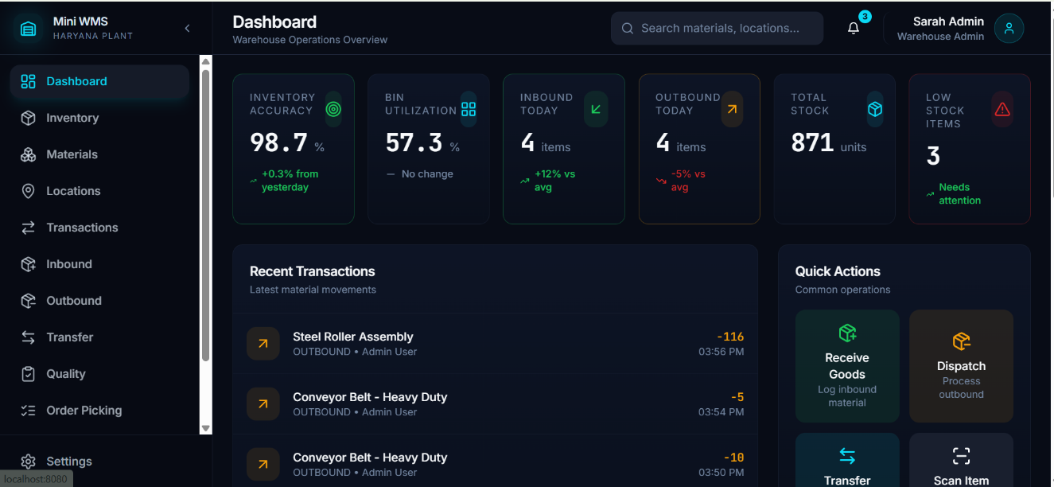

WEEK–6
Overall Learning & Review
- Reviewed concepts learned during the internship.
- Understood integration of networking, servers, and software systems.
- Gained hands-on exposure to automation-supporting IT infrastructure.
- Improved problem-solving and real-world system understanding.

Conclusion
The 6-week automation training at BEUMER Group provided strong foundational knowledge in networking, server infrastructure, software development, and automation systems. The hands-on projects and Smart StockFlow WMS development helped bridge the gap between theory and real-world industrial applications.

Report Prepared By:
Mandeep Rana

